**DBMS 1st Internal**

1)Define Data and Information.?

A)Data can be defined as a representation of facts, concepts, or instructions in a formalized manner, which should be suitable for communication, interpretation, or processing by human or electronic machine.

Information is organized or classified data, which has some meaningful values for the receiver. Information is the processed data on which decisions and actions are based.

2)Define Database and Database Management System.?

A)The database is a collection of inter-related data which is used to retrieve, insert and delete the data efficiently.

For example: The college Database organizes the data about the admin, staff, students and faculty etc.

Database management system is a software which is used to manage the database.DBMS provides an interface to perform various operations like database creation, storing data in it, updating data, creating a table in the database and a lot more.

For example: MySQL, Oracle, etc are a very popular commercial database which is used in different applications.

3)Define Advantages of DBMS?

A) Controls database redundancy: It can control data redundancy

​Data sharing: In DBMS, the authorised users of an organization can share the data among multiple users.

Easily Maintenance: It can be easily maintainable due to the centralized nature of the database system.

Reduce time: It reduces development time and maintenance need.

Backup: It provides backup and recovery subsystems which create automatic backup of data from hardware and software failures and restores the data if required.

​Multiple user interface: It provides different types of user interfaces like graphical user interfaces, application program interfaces

4)Who is Database Administrator (DBA)? Explain it?

A)Database Administrator (DBA) is a person/team who defines the schema and also controls the 3 levels of database.The DBA will then create a new account id and password for the user if he/she need to access the data base.DBA provides security to the data base , he allows only the authorised users to access/modify the data

5)Who is sophisticated user? Explain it

State any 4 difference between Data & Information?

A)Sophisticated users can be engineers, scientists, business analyst, who are familiar with the database

Data are text and numerical values

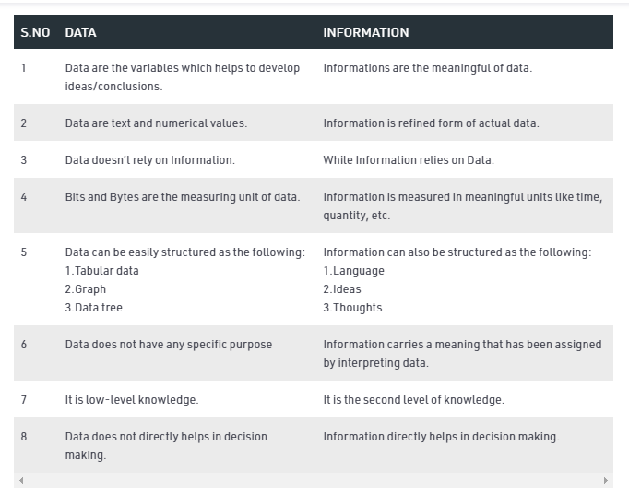

Any four questions. Each carries five marks.

1)Explain Characteristics of DBMS?

* **Real-world entity** − A modern DBMS is more realistic and uses real-world entities to design its architecture. It uses the behavior and attributes too. For example, a school database may use students as an entity and their age as an attribute
* **Relation-based tables** − DBMS allows entities and relations among them to form tables. A user can understand the architecture of a database just by looking at the table names.
* **Isolation of data and application** − A database system is entirely different than its data. A database is an active entity, whereas data is said to be passive, on which the database works and organizes.
* **Less redundancy** − DBMS follows the rules of normalization, which splits a relation when any of its attributes is having redundancy in values
* **Consistency** − Consistency is a state where every relation in a database remains consistent. There exist methods and techniques, which can detect attempt of leaving database in inconsistent state. A DBMS can provide greater consistency as compared to earlier forms of data storing applications like file-processing systems.
* **Query Language** − DBMS is equipped with query language, which makes it more efficient to retrieve and manipulate data. A user can apply as many and as different filtering options

2)What is data model? Explain types of datamodel?

A) The **Data Model** is defined as an abstract model that organizes data description, data semantics, and consistency constraints of data.

The data model emphasizes on what data is needed and how it should be organized instead of what operations will be performed on data.

There are 3 types of data model

**1. Conceptual Data Model (High Level)**

* A **Conceptual Data Model** is an organized view of database concepts and their relationships.

The purpose of creating a conceptual data model is to establish entities, their attributes, and relationships

The 3 basic tenants of Conceptual Data Model are

* **Entity**: A real-world thing
* **Attribute**: Characteristics or properties of an entity
* **Relationship**: Dependency or association between two entities

**2. Logical Data Model**

* The **Logical Data Model** is used to define the structure of data elements and to set relationships between them.
* The logical data model adds further information to the conceptual data model elements.

**3. Physical Data Model (Low level)**

* A **Physical Data Model** describes a database-specific implementation of the data model.
* It offers database abstraction and helps generate the schema. This is because of the richness of meta-data offered by a Physical Data Model.

3)Explain 3 tier architecture of DBMS with neat sketch?

A)

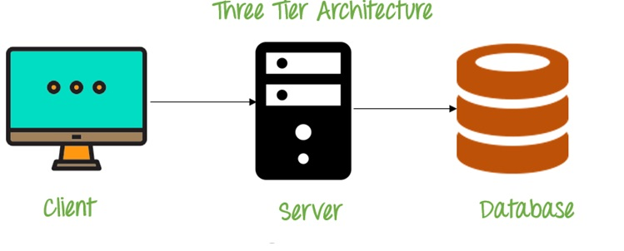

* A **3 Tier Architecture** in DBMS is the most popular client server architecture in DBMS in which the development and maintenance of functional processes, logic, data access, data storage, and user interface is done independently as separate modules.
* 3-Tier database Architecture design is an extension of the 2-tier client-server architecture.

A 3-tier architecture has the following layers:

* + Presentation layer (your PC, Tablet, Mobile, etc.)
  + Application layer (server)
  + Database Server

**The goal of Three Tier client-server architecture is:**

* To separate the user applications and physical database
* To support DBMS characteristics
* Program-data independence
* Supporting multiple views of the data

**Three Tier Architecture Example:**

Any large website on the internet, Flip kart, IRCTC

4)What is data independence? Explain its two types?

Data independence refers characteristic of being able to modify the schema at one level of the database system without altering the schema at the next higher level.

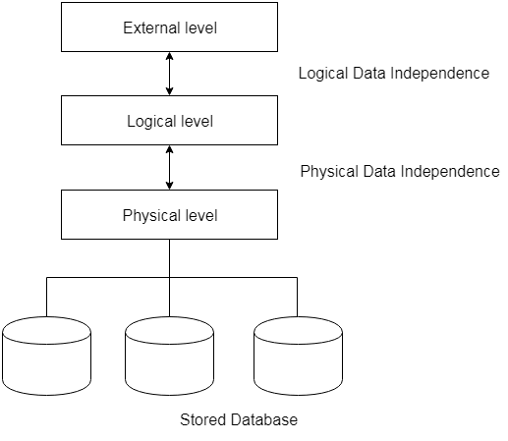

1. **Logical Data Independence**

* Logical data independence refers characteristic of being able to change the conceptual schema without having to change the external schema.
* Logical data independence is used to separate the external level from the conceptual view.

**2. Physical Data Independence**

* Physical data independence can be defined as the capacity to change the internal schema without having to change the conceptual schema.
* If we do any changes in the storage size of the database system server, then the Conceptual structure of the database will not be affected.

5)Explain Types of Client Server Architecture.

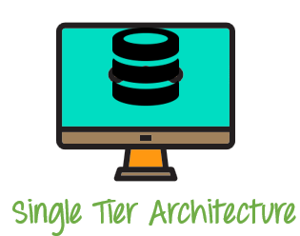

**1 Tier Architecture** in DBMS is the simplest architecture of Database in which the client, server, and Database all reside on the same machine.

* A simple one tier architecture example would be anytime you install a Database in your system and access it to practice SQL queries.

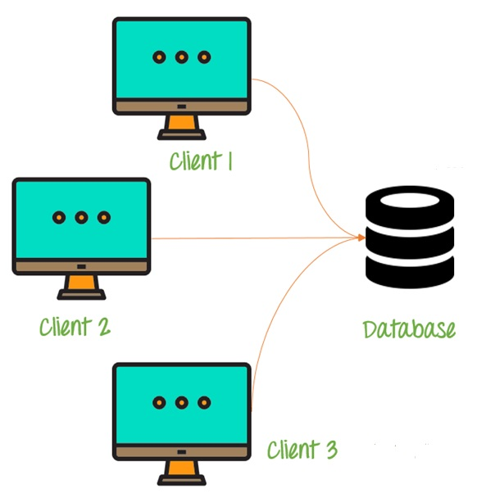

* A **2 Tier Architecture** in DBMS is a Database architecture where the presentation layer runs on a client (PC, Mobile, Tablet, etc.), and data is stored on a server called the second tier.
* Two tier architecture provides added security to the DBMS as it is not exposed to the end-user directly.



* A **3 Tier Architecture** in DBMS is the most popular client server architecture in DBMS in which the development and maintenance of functional processes, logic, data access, data storage, and user interface is done independently as separate modules.
* 3-Tier database Architecture design is an extension of the 2-tier client-server architecture.